

HAWAI‘I CIVIL RIGHTS COMMISSION

2012-2013 Annual Report

Neil Abercrombie, Governor

Dwight Takamine, Director
Department of Labor & Industrial Relations

Linda Hamilton Krieger
Commission Chair

William Hoshijo
Executive Director

830 Punchbowl Street, Room 411
Honolulu, Hawai‘i 96813
Phone (808) 586-8636
Fax (808) 586-8655

Table of Contents

Mission Statement .......................................................................................... 3

Overview ....................................................................................................... 3
- The State of Hawai‘i’s Constitutional Civil Rights Mandate ……………… 3
- The HCRC’s Highest Priority Continues to be Restoring Civil Rights Law Enforcement Capacity ……………………………………………………........ 3
- Fair and Effective Enforcement – History and Structure of the HCRC....... 4
- An Effective and Uniform Enforcement Scheme ....................................... 5
- A Fair Administrative Process .................................................................. 5
- Civil Rights Law Enforcement: State & Federal Law................................... 6

Mediation Program........................................................................................... 7

Public Education and Outreach........................................................................ 9

Caseload Statistics .......................................................................................... 11
- Intake ......................................................................................................... 11
- Closures .................................................................................................... 13
- Employment Cases..................................................................................... 14
- Housing Cases .......................................................................................... 16
- Public Accommodations Cases................................................................... 16
- Access To State & State-Funded Services Cases .................................... 17
- Cause Cases ............................................................................................. 17

Case Settlements ............................................................................................ 18

Case Decisions ............................................................................................... 20

Legislation......................................................................................................... 21
Appendix .......................................................................................................... 22
- Overview .................................................................................................... 22
- Administrative Procedure ........................................................................... 22
- HCRC Commissioners ............................................................................... 28
- HCRC Staff ................................................................................................. 30

Mission Statement

The mission of the Hawai‘i Civil Rights Commission is to eliminate discrimination by protecting civil rights and promoting diversity through enforcement of anti-discrimination laws and education.

Overview

The State of Hawai‘i’s Constitutional Civil Rights Mandate

Article I, Section 5 of the Hawai‘i Constitution is the foundation of our state civil rights laws. It provides that: “No person shall … be denied the enjoyment of the person’s civil rights or be discriminated against in the exercise thereof because of race, religion, sex or ancestry.” There is no counterpart to this civil rights mandate in the U.S. Constitution.

The HCRC’s Highest Priority Continues to be Restoring Lost Civil Rights Law Enforcement Capacity

Since 2008, the Hawaiʻi Civil Rights Commission (HCRC) has lost 8 of 30 permanent positions. The loss of 3 of 11 (27%) permanent investigator positions has had a devastating impact on the HCRC’s capacity to timely and effectively investigate discrimination, from intake through investigation and disposition of complaints.

A comparison of the HCRC’s investigation caseload data from 2007 (before the recession), the resulting reduction in force, and current caseload data reflects a direct and critical impact on the efficacy of the HCRC as the state law enforcement agency responsible for investigation of complaints of discrimination in employment, housing, public accommodations, and state-funded services. The loss of experienced permanent staff due to RIF and abolishment of positions, hiring freezes and delays in hiring for remaining positions, compounded by loss of productivity due to furloughs and supplemental time off, has had a crippling impact on the HCRC’s capacity to carry out its statutory mandate.

In July of 2007, the HCRC’s investigation caseload was 247 cases. At the end September 2013, the investigation caseload was 436 cases, a 77% increase. The growing caseload, with fewer investigators, makes timely investigation difficult if not impossible. At the end of calendar year 2007, the HCRC investigation caseload was 281 cases. The age of those cases, from date of complaint filing was: 1 case more than two years old (0%); 62 cases (22%) between one-two years old; and 218 (78%) less than one year old.

At the end of September 2013, the growing caseload and loss of capacity caused dramatic increases in the age of cases in the investigation caseload of 436 cases: 108 cases (24.8%) more than two years old; 20 cases (4.6%) between 18 months - two years old; 55 (12.6%) between one year - 18 months old; and 253 (58%) less than one year old.

In addition, at the end of September 2013, the HCRC had 170 pending intakes, in which a complaint had not yet been filed. With the current intake caseload, complainants have to wait as long as 3-4 months from the time of initial contact and submission of a pre-complaint questionnaire for a scheduled intake interview, leading to high levels of frustration and increased risk of untimely filing. This is a serious concern, given the 180 day statute of limitations for filing an HCRC complaint, which is required for complainants to exhaust their administrative remedies and preserve their rights. Timely filing and service is in the best interest of both complainants and respondents in discrimination cases, increasing the likelihood of timely disposition of complaints.

The increase in the size and age of the investigation caseload is troubling in several respects. Meritorious and complex cases are taking longer to investigate to disposition. Older cases are more difficult to investigate, as witnesses are harder to locate and memories fade. As resources are focused on investigation of older cases, newer cases age and become old cases. Delay makes it more difficult to effectively investigate, conciliate, and litigate complaints, and causes frustration for both complainants and respondents. There is a direct relationship between loss of capacity in investigation staffing, delay, and diminished capacity to enforce the laws under HCRC jurisdiction and obtain just disposition of complaints.

The size and age of the investigation caseload and reduced staffing level has led the HCRC to consider administrative dismissal of complaints that cannot be timely investigated. This would temporarily alleviate the immediate investigation caseload problem, but at the expense of the HCRC’s enforcement mandate and responsibility.

With restored capacity, HCRC enforcement efforts will be re-focused on strong enforcement, with a strategic emphasis on dedicating resources to priority cases.

Fair and Effective Enforcement – History and Structure of the HCRC

The HCRC was organized in 1990 and officially opened its doors in January 1991. For twenty-two years the HCRC has enforced state laws prohibiting discrimination in employment (H.R.S. Chapter 378, Part I), housing (H.R.S. Chapter 515), public accommodations (H.R.S. Chapter 489), and access to state and state-funded services (H.R.S. §368-1.5). The HCRC receives, investigates, conciliates, and adjudicates complaints of discrimination.

The HCRC has five (5) uncompensated volunteer Commissioners. They are appointed by the Governor, with the consent of the Senate, based on their knowledge and experience in civil rights matters and commitment to preserve the civil rights of all individuals. The HCRC is attached to the Department of Labor & Industrial Relations (DLIR) for administrative purposes.

An Effective and Uniform Enforcement Scheme

Prior to the establishment of the HCRC, jurisdiction over state anti-discrimination laws was split among several state departments. Enforcement was limited and sporadic. State prosecution of discrimination complaints was virtually non-existent. Nearly all aggrieved were left with litigation of individual lawsuits as their only recourse. For complainants who could not afford private attorneys to seek remedies in court, there was no administrative process to adjudicate their claims. As a result, few employment discrimination cases were brought to court under state law, and there were few court interpretations of state law.

The intent of the legislature in creating the HCRC was “...to establish a strong and viable commission with sufficient ... enforcement powers to effectuate the State’s commitment to preserving the civil rights of all individuals.”
The cornerstone of the HCRC statutory scheme was the establishment of a uniform procedure “...designed to provide a forum which is accessible to anyone who suffers an act of discrimination.”

Fair Administrative Process

The HCRC is committed to, and its procedural safeguards are structured to ensure fairness to both complainants and respondents. The HCRC is divided into two separate and distinct sections: a) the enforcement section, which receives, investigates, and prosecutes discrimination complaints; and b) the adjudication section which conducts hearings, issues orders and renders final determinations on complaints of discrimination filed with the HCRC.

The Commissioners have delegated HCRC enforcement authority to the Executive Director. The Commissioners have authority to adjudicate and render final decisions based on the recommendations of their Hearings Examiner, and oversee the adjudication section through their Chief Counsel.

The Commissioners, Chief Counsel, and Hearings Examiner are not involved in or privy to any actions taken by the Executive Director in the investigation and pre-hearing stages of the HCRC process. Likewise, the Executive Director and enforcement section are not permitted to communicate ex parte with the Commissioners, Chief Counsel or Hearings Examiner about any case.

The HCRC investigates complaints of discrimination as a neutral fact-gatherer. At the conclusion of an investigation, a determination is made whether or not there is reasonable cause to believe unlawful discrimination has occurred.

The law requires filing of a complaint with the HCRC in most (but not all) cases before filing a discrimination lawsuit in state court. Otherwise, the state courts will dismiss a lawsuit for failure to exhaust administrative remedies. This requirement reduces court caseloads by eliminating claims which are non-jurisdictional, or non-meritorious, or complaints that are closed or settled through the HCRC administrative process. As a result, the great majorities of cases filed with the HCRC are resolved, reach disposition, and are closed without resort to the courts.

Civil Rights Law Enforcement: State & Federal Law

Federal fair employment and fair housing laws are enforced by the U.S. Equal Employment Opportunity Commission (EEOC) and U.S. Department of Housing and Urban Development (HUD), respectively. Pursuant to work share and cooperative agreements, both EEOC and HUD rely on the HCRC to investigate complaints filed under both state and federal law (“dual-filed” complaints). Both EEOC and HUD contracts require maintenance of state effort and dedication of state resources for investigation of dual-filed complaints.

While Hawai‘i and federal fair employment and fair housing laws are similar, they are not identical. Hawai‘i has more protected bases than federal law, and there are substantial differences in the definition of “employer” and the statute of limitations for filing charges of employment and housing discrimination. In addition to these jurisdictional differences, Hawai‘i law provides stronger protections against pregnancy discrimination and sexual harassment in employment.

The greater protections in Hawai‘i law are attributable to the strong civil rights mandate contained in the Hawai‘i State Constitution, HCRC statutes, HCRC rules, HCRC Commission decisions, and state court interpretations. In contrast, federal court interpretations of federal civil rights laws have historically resulted in narrower protections against discrimination. The issue of state versus federal standards is an important one, particularly in states like Hawai‘i that have a strong commitment to equal opportunity and non-discrimination.

Mediation Program

The HCRC's voluntary mediation program completed its fourteenth full year on June 30, 2013. The program enjoyed one of its most successful years, despite operating without an Administrative Assistant – Mediation Coordinator who had previously overseen the program. The position has been vacant since the passing of the long-time Mediation Coordinator in 2011. The HCRC has been working on re-describing the position and filling it, subject to delays due to budget constraints. While this position has been vacant, the HCRC has used other enforcement staff, including managers and investigators, to run the mediation program, taxing already reduced enforcement capacity.

Complainants, respondents and the HCRC, with the strong support of the Commissioners, want prompt and fair resolutions to discrimination complaints. To help accomplish this goal, the HCRC developed its voluntary mediation program, a process in which neutral third persons (often a team of two co-mediators with at least one attorney-mediator) help the parties discuss, clarify and settle complaints.

The HCRC voluntary mediation program uses trained community mediators who are unbiased and do not rule on the merits of the complaint. The HCRC provides the mediators with the basic facts of each case needed to understand the dispute. The mediators then assist the parties to reach voluntary agreements. These agreements may include apologies, policy changes, monetary settlements, or other appropriate solutions. Mediation saves time, money and resources. It also eliminates the stress of litigation and allows the parties to explain their side of the case and to control the process of resolving the disputes in a non-adversarial manner.

The HCRC works with trained, senior mediators from the Mediation Centers of Hawaii (MCH), a statewide network of community non-profit mediation centers. MCH utilizes a facilitative approach to mediation. MCH mediators receive training on civil rights laws and settling disputes by HCRC and MCH staff on a regular basis. The HCRC mediation coordinator facilitates the process by explaining, encouraging, referring, and reviewing mediation and its benefits to the parties. There are mediation centers on O‘ahu (Mediation Center of the Pacific), Maui (Mediation Services of Maui), east Hawai‘i (Ku‘ikahi Mediation Center in Hilo), the West Hawai‘i Mediation Center in Kailua-Kona, and Kaua‘i (Kaua‘i Economic Opportunity, Inc. Mediation Program). The centers charge fees on a sliding scale for the sessions, which can be waived or reduced if there is financial hardship.

Private mediation is also available if the parties choose. Private mediations generally utilize an evaluative approach, in which applicable law,and possible liability and damages are evaluated and discussed. Private mediation is an important part of the HCRC mediation program. Parties are free to select commercial private mediators who charge market rates or private mediators from the Access ADR program, a reduced fee program of the MCP.

Mediation can occur at any stage of the intake, investigation, conciliation, or hearing process. Mediation is first offered when the complaint is accepted. At this early stage disputes are often easier to resolve because the facts are fresh, damages may not have accumulated, and the positions of the parties may still be fluid. However, parties may voluntarily choose mediation at any time during the HCRC investigative, conciliation or hearing process.

During FY 2013, 59 cases were referred into mediation, and 59 mediations were completed (dispositions). Of the 59 dispositions, 41 resulted in mediated settlements (69.5%), and 18 cases resulted in no agreement (30.5%). Of the 41 mediated settlements, 34 were in employment cases, and 7 were in public accommodations cases.

The total disclosed monetary value of mediated agreements was $190,637 with a wide variety of affirmative relief as well. (In 17 cases, the monetary consideration was subject to a confidentiality clause and not disclosed.) Mediation Center of the Pacific had 23 settlements; Mediation Services of Maui had 4 settlements; West Hawaii Mediation Center had 3 settlements; Ku`ikahi Mediation Services (Hilo) had 1 settlement; and there were 10 settlements with private mediators.

The primary bases of discrimination of the 41 settlements were as follows: Sex -- 4 (including 3 pregnancy and 4 sexual harassment); Disability -- 9; Retaliation -- 4; Arrest and Court Record -- 3; Sexual Orientation -- 3; Age -- 3; Marital Status -- 2; Ancestry -- 1; Color -- 1; National Origin -- 1. Many of the completed mediations also included charges on other protected bases. 28 mediated settlements were cases dual-filed with the EEOC.

Although monetary settlements were achieved in most agreements, almost all mediated agreements also involved some form of non-monetary affirmative relief. Examples of non-monetary relief include:

1) frank discussion of disputes, which often lay the groundwork for eventual settlement or restoration of the prior employment relationship;
2) reinstatement and/or restoration of employee benefits;
3) formal or informal apologies (by either or both sides);
4) increasing hours for part-time employees;
5) providing neutral or positive references for former employees;
6) removal of inappropriate negative comments in employee records;
7) provision of reasonable accommodations;
8) changing shifts when practicable;
9) policy revisions and postings; and
10) clarification of communications between employer and employee, leading to more productive working environments.

Public Education & Outreach

In addition to enforcing anti-discrimination laws, the HCRC is committed to preventing and eliminating discrimination through public education. The HCRC Commissioners and staff maintained or assisted in a number of civil rights public education efforts, working with civil rights, business, labor, professional, and non-profit organizations, on new and continuing initiatives.

The HCRC conducted its annual training in October 2012 at the Blaisdell Exhibition Hall, for over 260 attendees. The theme of the training was “EEO Updates and Understanding Reasonable Accommodations” and included an address on civil rights by HCRC Commission Chair Linda Krieger. The training featured panels on EEO updates, requests for accommodations, and the interactive process, as well as a mock mediation of a disability discrimination case involving an accommodation request. In addition, the winners of the E `Ola Pono Art & Video Competition, a statewide student contest co-sponsored by the HCRC, OHA, the UH Center on Disability Studies, the Jack Johnson Ohana Foundation, and Hawaiian Telcom, were presented by former Commissioner Sara Banks.

During FY 2013 the HCRC completed work on two projects funded through a U.S. Department of Housing and Urban Development (HUD) Partnership Initiative (PI) grant:

In the first of these HUD PI projects, the HCRC partnered with the Medical Legal Partnership for Children in Hawaiʻi (MLPC Hawaiʻi) to engage in targeted outreach to Compact of Free Association (COFA) immigrant communities. Often referred to as “Micronesians” in Hawaiʻi, these are people from the COFA nations of The Federated States of Micronesia (FSM)(Yap, Pohnpei, Chuuk, Kosrae), the Republic of the Marshall Islands, and the Republic of Palau. In partnership with the HCRC, MLPC Hawaiʻi hosted nine newcomer education / civil rights – fair housing workshops, eight on Oahu and one on Maui, reaching over 250 residents from COFA nations and more than 70 service providers and advocates who assist these resident families. The HUD PI funded project also included the production of four two-minute videos on the subjects of fair housing, fair employment, language access, and what to do if you are discriminated against, with voice-over versions in Chuukese, Ilocano, and Tagalog.

In the second HUD PI project, the HCRC partnered with Dr. Suzanne Zeng and Language Services Hawaiʻi to develop protocols for obtaining translations of outreach materials and vital documents.

During FY 2013 the HCRC continued to be an active participant in the fair housing committee, comprised of representatives from the housing departments of each county and the State, HUD Honolulu Field Office, Legal Aid Society of Hawaii, Fair Housing Enforcement Program, Hawai`i Disability Rights Center, Hawaiian Homelands, and other housing-related private and public entities. The committee met to learn and discuss the latest fair housing cases, legal issues, and recent developments in Fair Housing from a Federal, State and local perspective, to corroborate on local fair housing issues and concerns, and to work together to promote fair housing throughout the islands. The committee continued to corroborate on an annual joint private-public awareness fair housing campaign involving public service announcements on television, radio and print media.

The HCRC also worked with HUD, state and county housing agencies, community fair housing organizations, non-profit and for-profit organizations, and businesses to co-sponsor fair housing trainings on the Islands of Maui, Moloka`i, Kaua`i, Hawai`i, and O`ahu. Representative trainees in the housing area included the Board of Realtors, Property Managers Association, National Association of Residential Property Managers, Community Associations Institute (CAI) Hawaii, Hawaii Center for Independent Living (HCIL), landlords, tenants, homeless veterans, emergency shelter and transitional housing management/staff, case management staff, housing assistance/referral management/staff, and various property management companies and community associations. An estimated 500+ people took advantage of these informative and free trainings.

During FY 2013 the HCRC also conducted outreach and/or participated in the following:

- Joint outreach events with the U.S. Equal Employment Opportunity Commission
- Joint informal exchanges of information between HCRC and EEOC staffs
- William S. Richardson School of Law, University of Hawai‘i, various classes, panels and programs
- ALU LIKE, Inc.
- Outreach training for the Society of Human Resource Management – Hawai‘i Chapter
- Outreach training for the Business Leadership Network – East Hawai‘i Chapter
- Outreach training and flyers on assistance animals as a reasonable accommodation in housing
- Hawaii Paralegal Association
- Hawai’i Foodbank
- Aloha United Way
- March of Dimes
- Mediation Centers of Hawai’i
- Honolulu Pride Parade and Celebration
- Annual Martin Luther King, Jr. Holiday Parade and Festival
- Hawai‘i Friends of Civil Rights Annual Dinner
- Statewide Fair Housing Month events
- Oahu WorkLinks Job Quest Job Fair

The HCRC website is part of a consolidated website that includes all divisions of the Department of Labor & Industrial Relations. The HCRC relies on the DLIR webmaster for maintenance and updating of the HCRC website, as well as ongoing efforts to improve accessibility and user-friendliness of the site. The site continues to attract broad public interest, particularly to those pages on administrative rules, case decisions, and the mediation program.

Caseload Statistics

During FY 2013, the HCRC continued its emphasis on maintaining efficiency without sacrificing effective law enforcement.

Intake

During FY 2013, the HCRC received 4,057 telephone and walk-in inquiries. HCRC investigators completed 732 intakes, and 615 discrimination complaints were filed with the HCRC, an average of 51.2 complaints a month.

Of the 615 complaints that were filed with the HCRC, 338 complaints originated with HCRC investigators (averaging 28.1 per month), and another 277 cases originated with the federal EEOC or HUD. These 277 cases were dual-filed under state law with the HCRC.

The 615 cases included 549 employment cases, 23 public accommodations cases, and 43 housing cases. The other inquiries and intake interviews did not lead to filed charges due primarily to: a) lack of jurisdiction; b) failure to correlate the alleged act(s) with the protected bases; or c) the complainant's decision not to pursue the complaint.

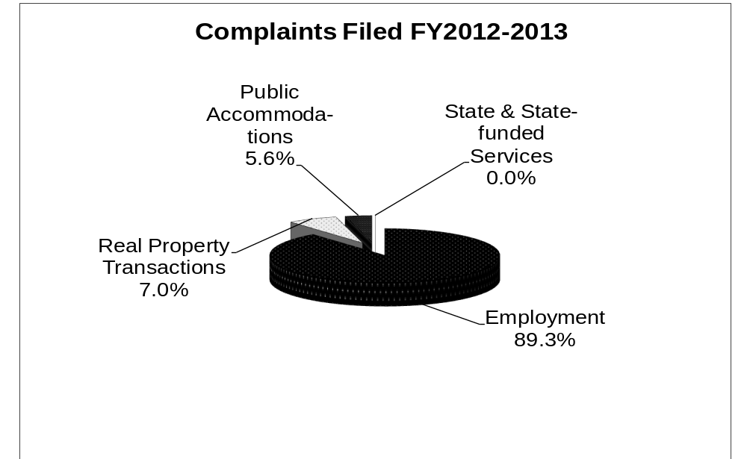

The 615 charges accepted by the HCRC consisted of 429 Oahu complaints, 70 Hawai’i County complaints, 69 Maui County complaints, and 47 Kauai County complaints. The number of complaints filed from each county was consistent with its proportion of resident population in the state (Honolulu County 70.1%; Hawai'i County 13.7%; Maui County 11.2%; and Kauai County 5.0%).

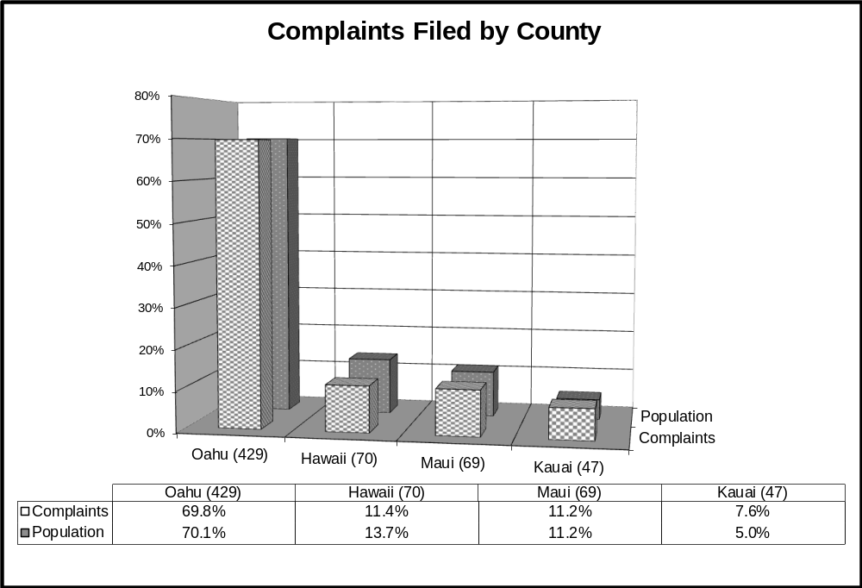

Closures

HCRC investigators and attorneys closed 355 cases during FY 2013 (an increase of 11 cases from FY 2012), for an average closure rate of 29.6 cases per month, up from 28.7 cases per month in FY 2012. HCRC investigations resulted in cause determinations in 3 cases. As of June 30, 2013, there were 523 cases pending with HCRC investigators.

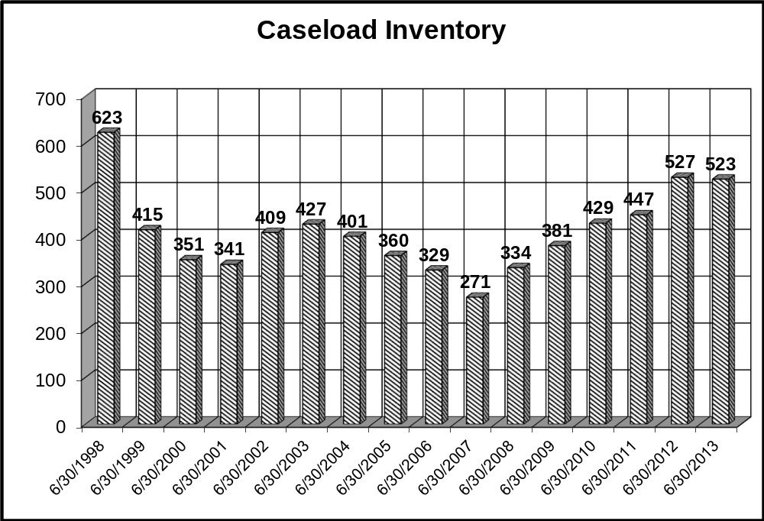

The average period for case closure by investigators was 438 days, as compared to 351 days for FY 2012, 363 days for FY 2011, and 326 days for FY 2010. A review of this fiscal year shows the following reasons for investigative closures:

 | No. of Cases | % of Subtotal | % of Total Closures
Merit Closures
Resolved by Parties | 62 | 20.60% | 17.46%
Pre-Determination Settlements | 19 | 6.31% | 5.35%
Cases Resolved by Attorneys | 6 | 1.99% | 1.69%
No Cause Determinations | 214 | 71.10% | 60.28%
Subtotal | 301 | 100.0% | 84.79%
Non-merit Closures | No. of Cases | % of Subtotal | % of Total Closures
Complainant Elected Court Action | 30 | 55.56% | 8.45%
No Jurisdiction | 2 | 3.70% | 0.56%
Complaint Withdrawn | 2 | 3.70% | 0.56%
Complainant Not Available | 3 | 5.56% | 0.85%
Complainant Failed to Cooperate | 12 | 22.22% | 3.38%
Bankruptcy of Respondent | 1 | 1.85% | 0.28%
No Significant Relief Available | 4 | 7.41% | 1.13%
Subtotal | 54 | 100.00% | 15.21%
Total Number of Closures | 355 |  | 100.00%

Employment Cases

H.R.S. Chapter 378, Part I prohibits discriminatory employment practices based on race, sex, sexual orientation, age, religion, color, ancestry, disability, marital status, arrest and court record, domestic or sexual violence victim status, credit history or credit report, assignment of income for child support obligations, National Guard participation, and breast feeding/expressing milk. Examples of such practices are outlined in H.R.S. §378-2.

The HCRC has a work-share agreement with the EEOC. Under the work-share agreement, a case is filed with both agencies where there is concurrent jurisdiction. However, only the intake agency conducts the investigation, thereby eliminating duplicate enforcement activity. During the fiscal year a total of 549 employment cases were accepted by the HCRC. The HCRC was the intake agency for 272 of these cases, and the HCRC dual-filed another 277 cases originating with EEOC. Of the HCRC-originated cases, 76.5% were also filed with EEOC.

Of the 549 employment complaints filed, the bases most cited were sex, in 154 cases (28.1%); disability, in 108 cases (19.7%); and retaliation in 97 cases (17.7%). Of the sex discrimination complaints, 35 (22.7% of all sex cases) alleged sexual harassment and 28 (18.2% of all sex cases) were based on pregnancy. Race was the fourth most cited basis with 61 cases, representing 11.1% of all employment cases, followed by age in 55 cases (10.0%), ancestry/national origin in 42 cases (7.7%), arrest and court record in 16 cases (2.9%), and religion in 5 cases (0.9%). The bases of color, sexual orientation, and domestic or sexual violence victim status were cited in 3 cases each (0.5%), and marital status was cited in 2 cases (0.4%). There were no cases based on credit history or credit report, child support obligations, or National Guard participation.

The case closure period averaged 457 days for the 282 employment cases that were closed or caused by HCRC investigators during FY 2013.

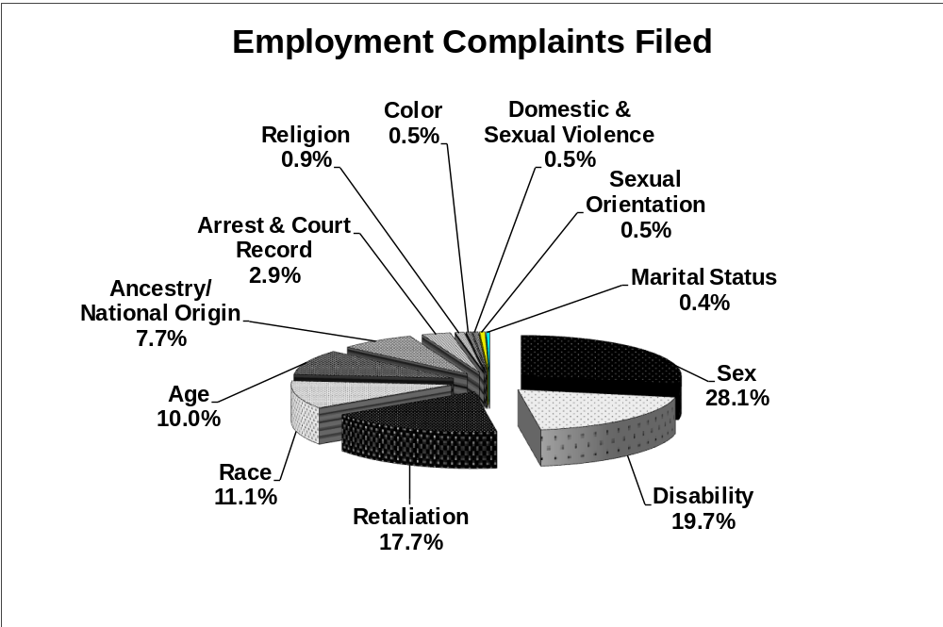

Housing Cases

During FY 2013, the HCRC accepted 43 cases of housing discrimination. There were 20 cases based on disability (46.5%); followed by 6 cases based on race (14.0%); 5 cases based on retaliation (11.6%); 4 cases based on familial status (9.3%); 3 cases based on ancestry/national origin (7.0%); 2 cases based on marital status (4.7%), and 1 case each based on age, religion, and sexual orientation (2.3%). There were no cases based on HIV infection, color, or sex.

Housing case closures averaged 291 days for the 44 cases closed or caused during FY 2013.

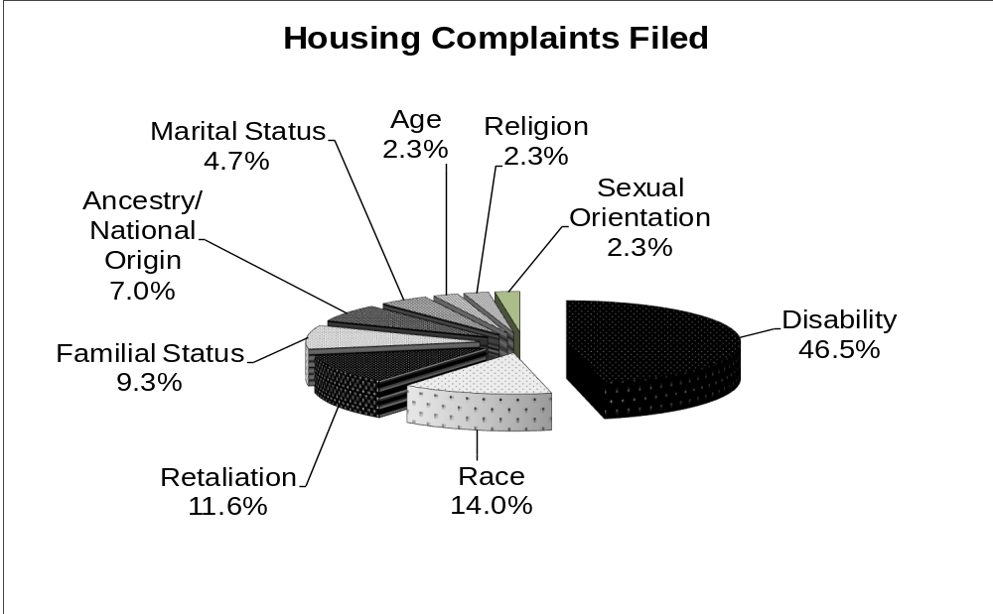

Public Accommodations Cases

H.R.S. Chapter 489 prohibits unfair discriminatory practices that deny, or attempt to deny a person the full and equal enjoyment of the goods, services, facilities, privileges, advantages or accommodations of a place of public accommodation on the basis of race, sex, sexual orientation, color, religion, ancestry, or disability. Public accommodations include retail stores, restaurants, theaters, sports arenas, public transportation, healthcare providers, hotels, and banks.

During the fiscal year, 23 new cases of public accommodations discrimination were accepted. Of these, 7 cases were based on disability discrimination (30.4%); 6 cases were based on race (26.1%); 5 cases were based on sex (21.7%); 3 cases were based on color (13.0%); and 2 cases were based on ancestry (8.7%). There were no cases based on religion or sexual orientation.

Public accommodations case closures averaged 357 days for the 24 cases closed (or caused) during FY 2013.

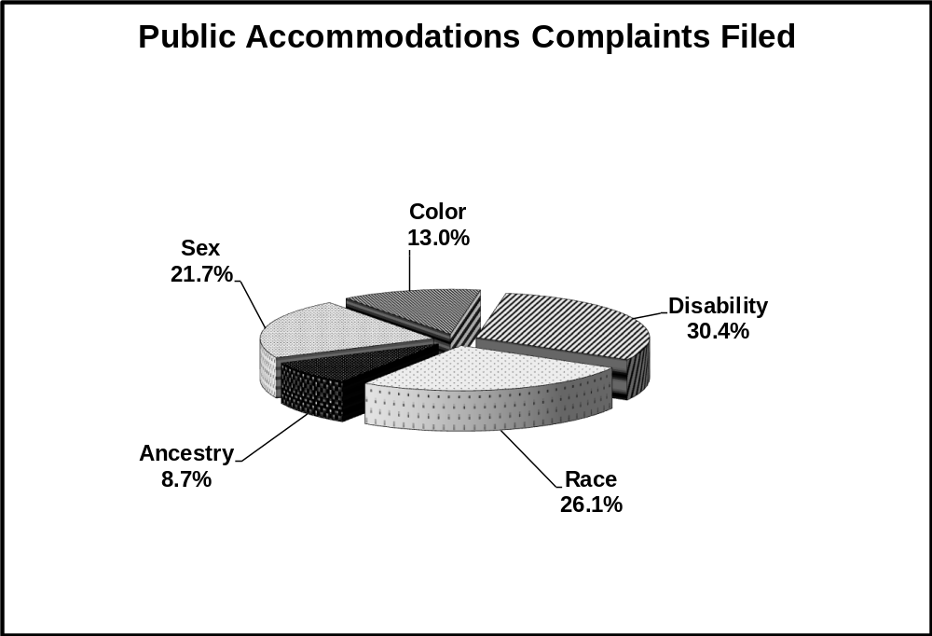

Access to State and State-Funded Services Cases

H.R.S § 368-1.5 prohibits state agencies, or any program or activity receiving state financial assistance from excluding from participation, denying benefits or otherwise discriminating against persons with disabilities (the only protected class under this statute).

During the fiscal year, there were no cases filed under § 368-1.5. During FY 2013 there were two cases filed under § 368-1.5 that closed, averaging 611 days per closure.

Cause Cases

When the investigation results in a recommendation that there is reasonable cause to believe that discrimination has occurred, the case is assigned to an HCRC enforcement attorney for legal action. In FY 2013, 3 recommendations for cause were brought forward for legal action. Of these cases, 2 (66.7%) were housing cases, and 1 (33.3%) was an employment case.

Of the 3 investigations with a cause recommendation, 2 were based on disability (66.7%), and 1 was based on age (33.3%).

In addition, HCRC attorneys continued to work on cause cases carried forward from previous years, engaging in legal review, conciliation, and litigation.

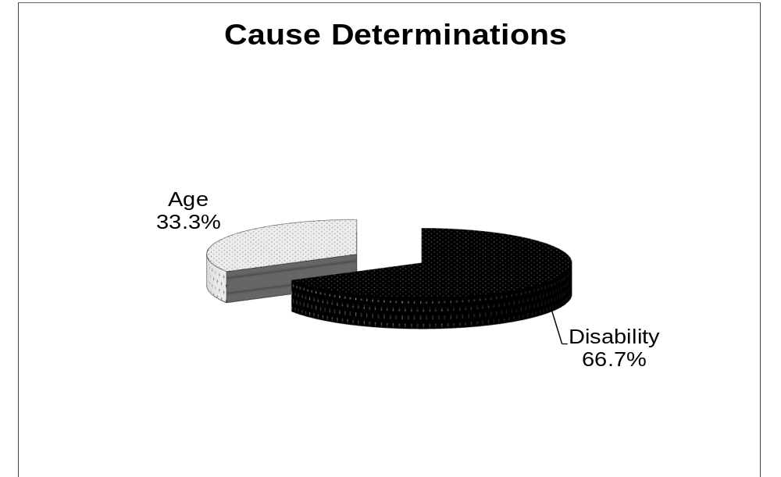

Case Settlements

The HCRC promotes and encourages settlement during all stages of the complaint process. Through pre-determination settlements, mediation, and conciliation, the HCRC obtains relief and resolves complaints while avoiding unnecessary litigation. These settlements provide closure for the parties and conserve HCRC investigation and litigation resources for complex or precedent setting cases.

During FY 2013 the HCRC continued to successfully obtain monetary relief through settlement of complaints. In the 4 cause cases that were settled, HCRC attorneys obtained monetary settlements totaling $75,700. Of the 81 cases settled prior to an investigative finding, 39 of those cases involved confidential settlements, the terms of which were not disclosed to the HCRC. Of the remaining 42 cases settled prior to an investigative finding, monetary relief totaled $262,154. This figure includes pre-determination settlements obtained through HCRC investigators and settlements between the parties ($71,517), as well as investigative settlements obtained through the HCRC mediation program ($190,637). Collectively the HCRC’s known monetary settlements for FY 2013 totaled $337,854. Since the settlement terms are unknown for 39 closed cases, the actual total figure for all monetary settlements in FY 2013 is probably significantly higher than $337,854.

In addition to monetary relief, significant affirmative relief was obtained. The HCRC seeks affirmative relief for four basic reasons: to enforce civil rights laws, stop discriminatory conduct, prevent future harm to complainants, and assist respondents in avoiding future violations. HCRC settlements and conciliation agreements routinely contain various types of affirmative relief including the development and implementation of non-discrimination policies, employee and supervisor training on non-discrimination policies, posting non-discrimination policies, and publishing notices informing the public of the HCRC’s role in enforcing state non-discrimination laws.

In some instances, non-monetary relief can be an important element of a settlement. For example, in FY 2013, there were complainants who received letters of apology pursuant to the terms of a settlement. A simple apology sometimes goes a long way towards healing the rift between a complainant and respondent, and this form of relief is often not available as a court ordered remedy. Some cases were resolved when an employer, housing provider, or public accommodation corrected an unlawful discriminatory policy or practice after notice of the violation. During FY 2013, a significant number of employers, housing providers, and public accommodations voluntarily agreed to correct unlawful employment applications, leave policies, or house rules.

The following are illustrative of the HCRC cases that were resolved through conciliation or mediation and describe the relief obtained during FY 2013:

In a case involving disability discrimination in a place of public accommodation, the complaint settled for the posting of a non-discrimination policy, training of staff, and modification of facilities to increase access to persons with disabilities.

In an employment case involving sex (pregnancy) discrimination, the complaint settled for $29,000, review of a nondiscrimination policy, and a neutral job reference.

In a housing case involving familial status discrimination, the complaint settled for $1,000, adoption of a non-discrimination policy, training, and a letter of apology.

In an employment case involving discrimination on the basis of sex, sexual orientation, and retaliation, the complaint settled for $10,000, review and posting of a non-discrimination policy, and training of managers and supervisors.

In an employment case involving discrimination on the basis of arrest and court record, the complaint settled for $4,500 and consideration of the complainant for future employment opportunities.

In a housing case involving discrimination on the basis of disability and retaliation, the complaint settled for $300, posting of a non-discrimination policy, training, and a letter of apology.

HCRC Warning Letters

In an effort to prevent future or recurring problems, the HCRC provides respondents with “warning letters” advising them of potentially unlawful practices that the HCRC discovers during the course of its investigation of claims against the respondent. In those instances in where the HCRC investigation does not result in a recommendation of reasonable cause on the claims filed, and the HCRC investigator finds evidence of other unlawful practices (such as a discriminatory written policy, employment application, or conduct in the workplace that could rise to the level of unlawful harassment if repeated), the HCRC will advise the respondent of the potential violations and provide the respondent information about how it can correct the possible violation of the law. Warning letters have resulted in policy and application form changes, as well as discrimination prevention training for employees and managers.

Case Decisions

In AOAO of Lililuokalani Gardens v. Taylor, Civ. No. 11-00751 (D. Haw.), the HCRC filed an amicus brief in support of Defendant Taylor, who requested an accommodation to his condominium association’s “no pets” rule to allow him to keep an emotional support dog in his unit. The AOAO and Taylor filed cross motions for summary judgment on the two issues of: a) whether an animal must have special training in order to be a reasonable accommodation under federal and state fair housing laws; and b) the applicability of the decision in Prindable v. Assoc. of Apartment Owners of 2987 Kalakaua, 304 F. Supp. 2d 1245 (D. Haw. 2003) to the issue. The HCRC asserted that an untrained assistance animal may be a reasonable accommodation under HRS Chapter 515 because the relevant standard is not whether the animal has been specially trained, but whether the animal performs the disability-related assistance or benefit needed by the person with the disability. The HCRC also asserted that the decision in Prindable should not be followed because that case did not deal with a request for an untrained assistance animal as a reasonable accommodation. On August 31, 2012 the U.S. District Court agreed with these assertions and held that the AOAO could not deny an accommodation request for an emotional support animal merely because the animal had not received specialized training. This decision can be found at: 892 F. Supp. 2d 1268 (D. Haw. 2012).

On November 30, 2012 the HCRC filed an amicus brief in the case of Lales v. Wholesale Motors, Inc. (Hawaiʻi Supreme Court No. 28516). This case involved a claim of ancestry harassment against a supervisor and the employer. The HCRC asserted that individual supervisors and agents could be liable for discriminatory conduct under HRS § 378-2 and that an employer is strictly liable for supervisor harassment pursuant to HAR §§ 12-46-109(c) and 12-46-175(d). A decision by the Hawaiʻi Supreme Court is pending in this case.

On December 19, 2011 the HCRC intervened in Cervelli v. Aloha Bed & Breakfast , Civ. No. 11-1-3103-12 (First Circuit Court), a case involving a proprietor of a bed and breakfast establishment who refused to allow a same sex couple to stay at the B&B because of their sexual orientation. Defendant Aloha Bed and Breakfast asserted that it was subject to the fair housing law (HRS Chapter 515) and fell under the “tight living” exemption found in HRS § 515-4, which exempts a home owner from the state fair housing law if the home owner rents up to four rooms in a house the owner resides in. The parties filed cross motions for summary judgment on the issue of whether the bed and breakfast was governed by the fair housing law or the public accommodations law. On April 11, 2012 the First Circuit Court granted the Plaintiff’s and HCRC’s motion, holding that the B&B was a public accommodation under HRS Chapter 489 because it is an establishment that provides lodging to transient guests and services relating to travel, and that the B&B could not discriminate based on sexual orientation. The decision is presently on appeal at the Intermediate Court of Appeals.

Legislation

Two bills relating to civil rights were passed during the 2013 regular legislative session. Senate Bill 535, enacted as Act 248, amends HRS Chapter 378 to protect domestics against employment discrimination in the terms, conditions and privileges of employment, but not in hiring and firing. Protections include unequal pay and harassment. Under the new law it is illegal for an employer to discriminate against a domestic employee on these bases because of race, sex (including gender identity or expression), sexual orientation, age, religion, color, ancestry, disability or marital status. However, employers of domestics can choose who they want to work in their home and can hire and fire for any reason. Domestic work includes caring for a child, serving as a companion for the sick or elderly, housekeeping, cleaning, cooking or any other domestic service. Hawaii is the second state in the U.S. to enact such a law.

Senate Bill 532, enacted as Act 249, also amends HRS Chapter 378 to create a new Part to require reasonable break times and locations for breastfeeding employees. The law requires employers to post notices to inform employees of these requirements and allows employee to file a civil action for violations. Breastfeeding employees continue to be protected from discrimination under HRS § 378-2(7).

Appendix

Overview
The Hawai‘i Civil Rights Commission (HCRC) was established under Act 219, L. 1988, and Acts 386 and 387, L. 1989.
The HCRC’s enabling statute, H.R.S. Chapter 368, declares that discrimination because of race, color, religion, age, sex (including gender identity and expression), sexual orientation, national origin, ancestry, or disability in employment, housing, public accommodations, or access to services receiving state financial assistance is against public policy. Certain bases are not protected under all HCRC laws.
The HCRC exercises jurisdiction over Hawai‘i’s laws prohibiting discrimination in employment (H.R.S. Chapter 378, Part I), housing (H.R.S. Chapter 515), public accommodations (H.R.S. Chapter 489), and access to state and state-funded services (H.R.S. § 368-1.5). Under its statutory mandate, the HCRC receives, investigates, conciliates, litigates, and adjudicates complaints of discrimination, providing a uniform procedure for the enforcement of the state’s discrimination laws.
The HCRC has five (5) uncompensated volunteer Commissioners who are appointed by the Governor, with the consent of the Senate, based on their knowledge and experience in civil rights matters and their commitment to preserve the civil rights of all individuals.
The HCRC is attached to the Department of Labor & Industrial Relations (DLIR) for administrative purposes. During FY 2012 the HCRC had 26 positions, divided into separate enforcement and adjudication sections.

Administrative Procedure
Before the HCRC accepts a complaint of discrimination, a complaining person must allege that:
- She or he has been subjected to unlawful discrimination¹ because of a protected bases,² and,
- The unlawful discrimination occurred within the previous 180 days.³
Where appropriate, after a complaint is filed with the HCRC, the parties are offered an opportunity to voluntarily mediate the complaint through the HCRC Mediation Program. If the parties agree to mediate, the HCRC mediation coordinator refers the parties to a community mediation center, which schedules and holds mediation sessions. Parties may alternatively choose to hire a private mediator.
In cases not referred to mediation, or those in which mediation is unsuccessful, an HCRC investigator conducts an objective, fact-finding investigation. HCRC investigators are impartial and gather evidence to allow the Executive Director to make a determination in each case. The HCRC investigator collects, reviews, analyzes documents, and contacts and interviews witnesses. Some witnesses may be identified by the complainant or by the respondent, and some are independent witnesses, including experts, who are identified by the investigator, by other witnesses, or are discovered during the course of the investigation. In many cases, the investigator also attempts to settle the complaint prior to an investigative determination (pre-determination settlement).
After an HCRC investigation is completed, H.R.S. 368-13(b)-(c) requires the Executive Director to determine whether reasonable cause exists to believe that discrimination has occurred. Where no reasonable cause is found, the Executive Director dismisses the complaint and issues a right to sue letter to the complainant. Where a determination of reasonable cause is recommended, the complaint is assigned to an HCRC enforcement attorney for legal review and final recommendation to the Executive Director.
Upon the issuance of a finding of reasonable cause to believe that unlawful discrimination has occurred, the HCRC enforcement attorney attempts to conciliate or settle the complaint.⁴ If conciliation is unsuccessful, the complaint is docketed for a contested case hearing. An HCRC enforcement attorney presents the case in support of the complaint before an impartial hearings examiner. The respondent (represented by themselves or by counsel or representative of their choice) is also given the opportunity to present his/her case at the hearing. Generally, a complainant may intervene in the contested case process as a party and also be represented by counsel or other representative of their choice.
After the completion of the contested case hearing, the hearings examiner issues a proposed decision based on the evidence. The five-member Commission Board then reviews the proposed decision and the hearing record. The parties may file written exceptions and support statements and present oral arguments to the Board. The Commission Board then accepts, rejects, or modifies the proposed decision, issues a final decision and order, and awards remedies, if appropriate. This decision is legally binding. If any party disagrees with the decision, she/he has 30 days to file an appeal to the State Circuit Court. Furthermore, a Respondent who appeals a decision of the Commission Board is entitled to a jury trial on any claims that form the basis for an award of common law damages.⁵
The HCRC enforcement and administrative hearing process is more cost effective than litigation in court. It provides for the investigation of complaints and access to justice for those who lack the resources to pursue their claims in court. This is particularly important in employment discrimination cases, where employees have often lost their source of income through termination and have little or no control over the evidence needed to prove discrimination.
The HCRC enforcement and adjudication process also funnels cases away from the courts, saving judicial resources and associated costs. Complainants who file suit in court must first exhaust administrative remedies by filing a complaint with the HCRC. The primary reason for this requirement is to prevent the courts from being overburdened with non-jurisdictional or non-meritorious complaints, or with complaints that can be closed or settled in the HCRC’s administrative process. In fact, the great majority of complaints filed with the HCRC are resolved or disposed of without resort to the courts.⁶
Although only a small number of cases are brought to administrative hearing and result in final Commission decisions, these cases are important because they create a body of legal precedent. Case law precedents, in Hawai‘i and across the United States, provide the basis for anti-discrimination principles, such as the doctrine of sexual harassment. Case law also establishes standards that define the rights and protections under civil rights laws, and give guidance to employers, landlords, and businesses on how to prevent and eliminate discrimination.

1 “Unlawful discrimination” may occur in any of the following ways:
- Disparate Treatment – this is the usual form of discrimination; it occurs when individuals are treated in an unequal manner because of a “protected basis." Examples of disparate (unequal) treatment include: firing an employee because of her race, her age, or because she is pregnant; refusing to serve a person because of his race or his disability; refusing to rent to a person because of her race; or refusing to rent to a family because it has young children.
- Reasonable Accommodation – this is the second most common way that discrimination appears; it occurs when an individual is denied a “reasonable accommodation” designed to allow an individual to have equal access or equal benefits. Examples of failure to accommodate include: refusing to allow a seeing impaired customer into a taxicab because he is accompanied by a seeing-eye dog; refusing to allow a pregnant cashier to sit on a stool so that she can work while pregnant; or refusing to make exceptions to a condominium association's "no pets” house rule to allow a disabled resident to keep a service animal.
- Disparate Impact -- the least common way that discrimination appears; however, when discrimination occurs in this form, it may impact the greatest number of people. Disparate impact occurs when a policy, practice, or test that has a “disparate impact” on persons with a particular “protected basis.” Examples of disparate impact include: a pre-employment test that includes a number of questions that are not job related but have the effect of disqualifying a large number women, or men, or any other protected basis.

² “Protected basis” is the criteria that it is unlawful for a respondent to discriminate upon. Protected bases vary depending on the statute involved:
- State Funded Services (Chapter 368, H.R.S.) The only protected basis is disability.
- Employment (Chapter 378, Part I, H.R.S.) The protected bases that an employer, employment agency, or labor organization may not discriminate on are: race, sex, sexual orientation, age, religion, color, ancestry, disability, marital status, arrest and court record or credit history.
- Public Accommodations (Chapter 489, H.R.S.) The protected bases that a public accommodation may not discriminate on are: race, sex (which includes gender identity and expression), sexual orientation, color, religion, ancestry, or disability.
- Housing (Chapter 515, H.R.S.) The protected bases that an owner, a real estate broker or any person engaging in a real estate transaction, may not discriminate on are: race, sex (which includes gender identity and expression), sexual orientation, color, religion, marital status, familial status, ancestry, disability, age or HIV (human immunodeficiency virus) infection.

³ Complaints filed with the HCRC usually involve a discrete act – such as termination, eviction, demotion, etc. – or involve acts that are ongoing and constitute a continuing violation. An example of a “continuing violation” is sexual harassment that began more than 180 days before the complaint is filed, but continued or ended less than 179 days before the complaint is filed. When discrimination involves a discrete act, such as termination, the HCRC can only accept a complaint within 180 days of that complained action.

⁴ During FY 2013, of all 355 investigative and attorney case closures, 8.45% (30) were closed on the basis of the complainant electing court action. The remaining cases (325) were closed on the following bases: in 60.28% of the cases (214), the Executive Director found no cause and dismissed the complaint, 22.81% (81) of the investigation cases were settled prior to a cause determination or were resolved by the parties, 1.69% (6) of the cases were resolved by staff attorneys, and the remaining 6.76% of the cases (24) were closed because there was no jurisdiction, the complaint was withdrawn, the complainant was unavailable and could not be located, the complainant failed to cooperate, no significant relief was available, or due to bankruptcy of the respondent.

⁵ The HCRC enforcement, hearing and appeal procedures are illustrated in Flowchart # 1. In SCI Management Corporation, et. al. v. Darryllynne Sims, et. al., 101 Hawai‘i 438, 71 P.3d 389 (2003), the Hawai‘i Supreme Court held that “a respondent who appeals a final order of the HCRC, pursuant to HRS § 368-16, is entitled to a jury trial on any claims that form the basis for an award of common law damages by the HCRC.” This does not apply to respondents in housing cases, who can elect to take the case to circuit court after a finding of reasonable cause under HRS §515-9.

⁶ HCRC contested case procedures are illustrated in Flowchart # 2.

HCRC Procedural
If no cause determination
Notice of Right to Sue issued
Circuit Court
Reasonable Cause Determination
Conciliation
Attempted
Final Conciliation Demand
Case Docketed
Hearing Examiner's Proposed Decision

Predetermination
Settlement
Request for Reconsideration
Chapter 91 Hearing
If settled, case closed
If settled, case closed
If settled,
case closed.

Hawai‘i Appellate Courts
Appeal to Circuit Court/
Jury Trial De Novo
Flowchart #1
Initial Inquiry
Intake Interview
Investigation
Complaint Filed
Voluntary
Mediation
If no jurisdiction, complaint not taken
If settled, case closed
Refer to Flowchart #2 for details.
Commission's Final Order
HCRC Contested
Case Flowchart #2

Appointment of Hearings Examiner & Docketing of Complaint
Scheduling Conference

Mediation
Settlement Conference
No Settlement Agreement
Settlement Agreement- Case Closed
Last day for Complainant to Request Right to Sue
Discovery/Motions Deadline
Pre-Hearing Conference
Settlement Conference
Exceptions to Proposed Decision
Statement in Support of Proposed Decision

Oral Argument to Commission
No Settlement Agreement
Settlement Agreement-Case Closed
No Settlement
Agreement
Settlement Agreement -
Case Closed
Administrative Hearing
Hearing Examiner's Proposed Decision
Commission's Final Order
Case Closed
Reconsideration
Appeal to Circuit Court/ Jury Trial De Novo

HCRC Commissioners

Linda Hamilton Krieger
Chair (term 2011-2015)
Linda Hamilton Krieger grew up in Hawai‘i and returned home in 2007 to join the faculty at the William S. Richardson School of Law as a Professor of Law and Director of the Ulu Lehua Scholars Program. Professor Krieger received a BA degree from Stanford University and is a graduate of New York University Law School. Prior to teaching, Professor Krieger worked for 13 years as a civil rights lawyer. From 1980-1986 she was a Staff Attorney and Director of Clinical Programs at the Employment Law Center of the Legal Aid Society of San Francisco, and from 1985-1991 she was a Senior Staff Attorney for the EEOC, San Francisco Regional Office. During that period, she litigated a number of significant state and federal sex and race discrimination cases in the areas of pregnancy discrimination and sexual harassment. She also played a significant role in drafting state and federal legislation in these subject matter areas. Professor Krieger has also published numerous articles on Title VII of the Civil Rights Act of 1964, disability discrimination, affirmative action, international comparative equality law and policy, and theories of law and social change.

Raymund Liongson
Commissioner (term 2011–2015)

Raymund Liongson is an Associate Professor and Coordinator of the Philippine Studies Program at Leeward Community College and the director of Sulong Aral, a program funded by the U.S. Department of Education to help students of Filipino ancestry finish college. He is a board member of the Filipino Community Center, and is also a member and past president of the Filipino Coalition for Solidarity, an advocacy group for Filipino American W.W. II veterans, immigrants and workers in the areas of discrimination, language access, domestic violence and sexual harassment. In 2010, Professor Liongson spearheaded Filipino census fairs in Waipahu and Kalihi to encourage those communities to participate in the 2010 census. In 2009, he was part of a fact-finding commission to investigate labor and management practices at the Pacific Beach Hotel and has been active in promoting job security, wage increases and better benefits for Filipino hotel workers. Professor Liongson received his M.A. in education from Northwestern University in the Philippines and Ph.D. in education from the University of the Philippines.

Kim Coco Iwamoto
Commissioner, (term 2012-2016)

Kim Coco Iwamoto is property manager/owner of Affordable Quality Apartment Rentals (dba AQuA Rentals, LLC). She most recently served the people of Hawai`i as an elected member of the State Board of Education from December 2006 – April 2011. Prior to this, Ms. Iwamoto was Managing Attorney at Volunteer Legal Services Hawaii and a volunteer at Legal Aid Society of Hawaii. Before becoming an attorney, Ms. Iwamoto interned at the Hawai`i Intermediate Court of Appeals, the New Mexico Supreme Court, the San Francisco Human Rights Commission and the Hawai`i Civil Rights Commission. Ms. Iwamoto was born on the island of Kauai and raised on Oahu. She is a graduate of St. Louis High School, received her BA in Creative Writing from San Francisco State University and her Juris Doctorate from University of New Mexico.

Wallace T. Fukunaga
Commissioner, (term 2012-2016)

Wallace Fukunaga is currently the Interim Executive Director of the Counseling and Spiritual Care Center of Hawaii. Prior to this, Rev. Fukunaga was a campus minister and lecturer at UH Manoa and was active in several land, anti-war and civil rights issues. Later Rev. Fukunaga became a legislative liaison for the Honolulu Community Action Program, advocating on behalf of the poor, and was an entrepreneur, serving as President of the self-start corporation, Northshore Resources, Inc., which was named “Small Business of the Year” by WorkHawaii.
In 1990 he returned to the ministry and served various congregations on Oahu and Kauai. He also served on the Board of Trustees of Pacific School of Religion, the Board of Governors of the Japanese Cultural Center of Hawaii, and the Boards of Directors of the Japanese American Citizens League and Interfaith Alliance of Hawaii. Rev. Fukunaga was born in Hawaii and graduated from McKinley High School. He received his BA from Harvard University, a Master of Divinity from Princeton Theological Seminary, and a Doctor of Ministry from the Pacific School of Religion.

Artemio Constantino Baxa
Commissioner, (term 2013-2017)

Artemio C. Baxa first practiced law in the Philippines. He received his law degree from the Ateneo De Manila University, a masters in comparative law from the University of Chicago Law School, and a juris doctorate at the University of Hawaiʻi William S. Richardson School of Law. In Hawaiʻi, Mr. Baxa was in private law practice with Lowenthal, August and Graham for five years and served as a Maui County deputy prosecutor for more than twenty five years. He is a retired Second Circuit Court judge, and is presently an appellate attorney with the Maui Prosecutor’s Office. Mr. Baxa served as President of the Maui County Bar Association, and as an officer/board director in various civic and community organizations, including Vice-President of the United Filipino Council of Hawaii, and Board member on Maui Catholic Charities of Hawaii (present), Maui County Charter Commission (2011-2012), and the University of Hawaiʻi Board of Regents (2008-2013). Mr. Baxa’s interest in civil rights began when he worked as a bellhop; when he served minorities and other underprivileged populations as a Community Aide, Child Care and Transportation Services Director, and Community Improvement and Development Coordinator in an anti-poverty program (MEO); as Maui County’s Deputy Director of Housing and Human Concerns; and when he prepared the report, “Filipino Immigration and Social Challenges in Maui County (1972)”, a comprehensive analysis of a countrywide survey of the needs and problems of Filipino immigrants in Maui County.

HCRC Staff

During FY 2012-2013 the HCRC staff consisted of 25 positions:*

- Enforcement Staff:
Executive Director
Deputy Executive Director
Enforcement Attorneys (3)
Administrative Assistant – Mediation Coordinator
Investigator-Supervisors V (2)
Investigator IV (8)
Investigator III-IV (temporary) (2)
Secretary III
Office Assistants (III-IV) (4)

- Adjudication Staff:
Acting Chief Counsel
Secretary II

1989 House Journal, Standing Committee Report 372.
Id.
The Chief Counsel position was frozen in FY 2009, unfunded in FY 2010 and then abolished in the FY 2011 budget. The Commissioners appointed the Hearings Examiner as Acting Chief Counsel, and currently appoints hearings examiners on a case by case basis.
Pursuant to HRS § 378-3(10) an employee may file a direct civil action for sexual harassment. Similarly, pursuant to HRS § 515-9(b), an aggrieved person may file a direct civil action for fair housing complaints. While the statutes allow these direct civil actions in these cases, only a small number are filed; the great majority still file complaints with the HCRC.
Hawaiʻi residents from COFA nations are often identified as “migrants” rather than “immigrants,” because in immigration law terminology immigrants are lawful permanent residents (LPRs), or “green card” holders; with their status under the COFA, Hawaiʻi residents from these nations are not LPRs. However, based on our experience with COFA communities in Hawaiʻi, we have consciously chosen to refer to these residents as immigrants rather than migrants, because use of the label “migrant” tends to imply a transitory status of people who do not have a stake in the community. Hawaiʻi residents from COFA nations are immigrants in the sense that they are here to stay, with emerging communities that are integral to our broader community and society.
? Analysis and Explanation of Closure Data This closure data does not reflect the number of completed investigations that result in cause determinations. Generally, the reason for this distinction is that cases are not closed upon issuance of a notice of cause, but are conciliated, and, if conciliation fails, are docketed for hearing. Historically, there is a relationship between the number of cause cases and predetermination settlements/resolutions between parties—the larger the number of notices of cause, the smaller the number of settlements/resolutions, and vice versa. Typically, cause determinations and settlements/resolutions constitute between 15-25% of the total of those cases that are either investigated to a cause/no cause determination or settled or resolved by predetermination settlement or resolution between the parties. During FY 2013, HCRC investigations resulted in 3 cause determinations, and 81 cases were closed on the basis of pre-determination settlement or resolution between parties. 214 cases were closed on the basis of no-cause determinations upon completion of investigation. The ratio of cause determinations and predetermination settlements/resolutions (84) to those cases that are either investigated to a cause/no cause determination or settled or resolved by predetermination settlement or resolution between the parties (295) for this fiscal year is 28.5%.
* Staffing levels reflect permanent (22) and temporary (3) positions which were either filled or vacant during FY 2013.

