Official Use
License #:
Approval Action |  | Initials | Amount | Check/Cash | Date
 | Approved
 | Denied
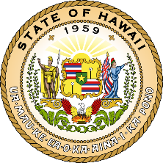
FIRE SYSTEMS TESTING APPLICATION
Hawaii State Fire Council
636 South Street
Honolulu, Hawaii 96813-5007
808.723.7169
Full Name | Date of Birth
Address | Telephone Number (Include Area Code)
City | State | Zip Code
Email | Cellular Telephone Number (Include Area Code)
Company Name (If Applicable) | Driver’s License Number
Company Address | Company Telephone Number (Include Area Code)
City | State | Zip Code
Fire Systems Testing Categories
 | Fire Alarm Systems (**Attach manufacturer’s certificate of training to this form**)
 | Fire Extinguishers
Non-Water-Based Fire Protection Systems (Incl kitchen hoods and dry chemical systems only)
**For other non-water-based fire protection systems check off the appropriate box below and attach manufacturer’s certificate of training to this form **
Halon
CO2
Foam
Wet Chemical
Other:
 | Water-Based Fire Protection Systems (Incl automatic sprinkler systems, private fire hydrants, spray booths/rooms)
 | Total # of Categories Checked
 | TOTAL AMOUNT SUBMITTED (total # of categories X $300.00)
I certify the information provided on this application by me is true and accurate to the best of my knowledge. I understand any false information provided herein could result in the revocation of my license.
Date | Print Name | Signature

