Workforce Parity for VR Candidates in Hawaii’s Workforce

The Division of Vocational Rehabilitation provides a variety of services to strengthen opportunities for Hawaii’s residents with disabilities to obtain and/or advance in employment, including self-employment. We also support our customers accessing resources for independent living.

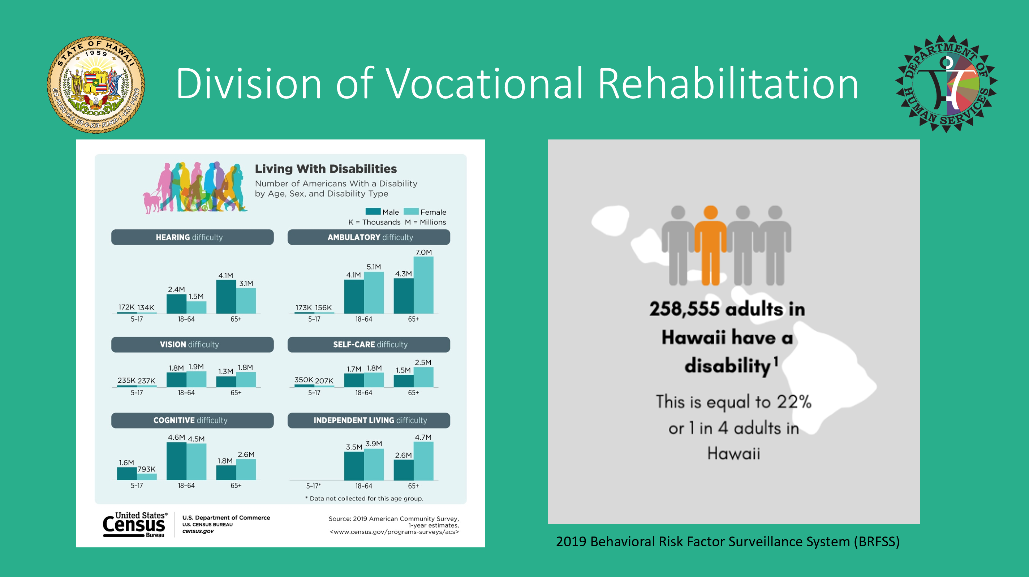

Throughout the past year, DVR’s staff have served more than 16,000 Hawaii residents with disabilities statewide through various programs with federal, State, and private funding, unduplicated by supports provided with our community partners. DVR staff also worked with over 290 employers to hire our clients throughout the pandemic. HDVR staff also collaborated with a host of community partners and supported more than 4,400 Hawaii residents in accessing resources to fulfill their independent living goals.

The following data for PY21 (Jul-Sep 2021) is based on preliminary data. Final data pending RSA-911 Quarter 1 report submission.
PY 21 (7/1/2021 – 9/30/2021)
Measure | Total
Participants served | 2,333
Participants exited | 81
Career Services - Participants served | 1,823
Career Service funds expended | $48,845
Training Services – participants served | 395
Training Services funds expended | $204,232
Service E placement – transitional work-based learning experiences | 16
Service E status | 194 (includes placements for PY 20)
Successful Rehabs* | 21
MSG Denominator | 325
Total MSG earned | 5
MSG Rate** | 1.5%
Participants with Supported Employment Goal | 330
Total # of SWD reported | 1,141
Total # of SWD receiving VR Pre-Employment Transition Services (Pre-ETS) | 960
Total # of Pre-ETS who applied for VR services  Note: DVR continues to work with DOE to increase the # of students who apply for VR services to support achievement of employment through work-based learning experiences or further educational goals | 386
WIOA Program Involvement (4th Quarter PY 20): 283 co-enrolled customers
Adult | 185
Adult Education | 17
Dislocated worker | 4
Job Corps | 3
Wagner Peyser | 14
Youth | 60
Youth Build | 3
* Number of hours working at exit range between 23-40 hours per week. Wage per hour rates range between $12-$33.75. Inclusive of the following occupations: Building and Grounds Cleaning and Maintenance, Business and Financial Operations, Healthcare Practitioners and Technical Occupations, Construction, Life-Physical-Social Science Occupations, Educational Instruction and Library, Food Service, Transportation and Material Moving

**Low number could be attributed to the timing of this report with the availability of required documentation in case management system to confirm MSG achievement. Under the Governor’s approved Hawaii State Unified Plan for 2020-2023, HDVR had a negotiated rate of 20% for measurable skills gains to be attained by June 30, 2021. Per ETA 9169 PY20 VR reported data, HDVR’s MSG Rate was 30.2% a 16.9% increase from 2019.
Current data shows there are at least 34,000 residents with disabilities who are still seeking employment. HDVR staff understand just 39% of Hawaii’s adults with disabilities were engaged in the workforce pre-pandemic, while earning 29% less than their non-disabled peers. In 2020 we’ve also learned that more than 18% of people with disabilities have lost employment furthering the gap of Hawaii’s unemployed residents with disabilities.

DVR continues our efforts on Strengthening Workforce Parity for VR Candidates

Our mission is to serve our participants, making them qualified candidates for employment in Hawaii’s workforce. Staff work as a team so participants can achieve their hopes and aspirations for meaningful employment through timely and individualized vocational rehabilitation services.
HDVR’s federal WIOA ETA 9169 PY20 performance outcomes report shows some opportunities for improvements. We have developed training and guidance for staff on the capturing of data related to Credential Attainment, and are working on developing reporting templates to monitor monthly progress.
ETA 9169 PY20 | Employment Rate Q2 after exit | Employment Rate Q4 after exit | Median Earnings 7/1/2019-6/30/2020 based on quarterly income totals | Credential Rate | MSG Gains
National | 48.6% | 44.0% | $4,280 | 23.2% | 43.3%
Hawaii (GDP $75.86 billion, Population 1.46 million) | 20.3% | 27% | $3,646 | 6.5% | 30.2%
California (GDP $3.7 trillion) | 46.5% | 37.8% | $5,807 | 23.6% | 40.4%
North Dakota (GDP $52.02 billion) | 58.9% | 57.7% | $4,047 | 52.5% | 68%
Maine (GDP $67,129 billion) | 43.8% | 42.1% | $4,119 | 33.3% | 47.6%
Puerto Rico (GDP $103 billion) | 41.1% | 26% | $3,915 | 35.2% | 34%
DC (GDP $122,11 billion) | 35.9% | 26.6% | $5,390 | 18.4% | 36.3%
Idaho (GDP $74.08 billion, Population 1.85 million) | 58.9% | 57.3% | $4,259 | 40.3% | 52.6%
Wisconsin (GDP $344,500 billion) | 49.1% | 46.8% | $2,738 | 28.8% | 47.2%
The data doesn't always elaborate on the details of the quality of HDVR’s job placements, the stories of VR candidates obtaining jobs, and their employers engagement activities with HDVR.

Here is a recent job placement Success Story:
We have worked with a young man with a visual impairment since he was 14 years old. Today he is 27 years old, and upon completing his college studies supported by DVR’s counseling staff at the Services for the Blind Branch (SBB), Ho`opono program, he has accepted an offer to work with Amazon. DVR’s staff supported this resident in fulfilling their employment goals through our various programs, providing counseling, training, blindness skills, summer work experiences and confidence-building activities, as well as assisting him with completing his 4-year college degree in IT. Staff helped him with learning and creating a video resume, honing interviewing skills, and assisting with him in his career search.
He signed a contract with Amazon and started working February 1 with their IT Help Desk earning an annual salary of $64K. He will work for the first 6 months remotely from Hawaii, and afterwards move to Virginia to work for Amazon.
Other Workforce Development Updates:
- Business Highlights meetings hosted by DVR engage employers with DVR staff to learn about job skills and employment opportunities available, as well as explore work-based learning experiences for VR participants and SWD.
  - Presentation from Hyatt Hotels and Queen’s Healthcare Systems
    - These meetings engage employers with DVR staff to learn about job skills and employment opportunities, as well as explore work-based learning experiences for VR participants and SWD.
- Healthcare Sector: Development of WBLE with CVS Healthcare and Queen’s Healthcare Systems pending execution of MOAs.
- Participated in Manufacturing Day – Promoting growth in this sector by supporting business and exploring work-based learning experiences (WBLE) and other career pathways for VR participants.
- MOA with DBEDT pending execution. In response to the economic impact from the COVID-19 pandemic and in support of the Governor’s digital economy initiative, DBEDT procured one-year memberships for 2,000 people to access the FlexJobs Corporation’s services. FlexJobs services include skills assessments, micro-lessons focused on skills that are particularly useful in today’s remote work environment, a job-seeker orientation webinar, jobs tip sheets to help point job seekers to employers offering remote jobs, and members-only access to virtual job fairs, hiring events, and special employer spotlight webinars. HDVR hopes that FlexJobs services will also assist persons with disabilities in finding competitive, integrated employment opportunities.
  - Hawaii Rural Water Association Apprenticeship Program

- Partnership Agreements
  - Executed MOU with DBEDT in December 2021
    - DBEDT provide DVR memberships for 100 people to access FlexJobs online job search services to provide remote work opportunities for unemployed and underemployed persons with disabilities. Users will be signed up by June 2022 and each membership continues for 1 year from date of activation, with monthly tracking of information on successful hiring.

  - CVS Health– DVR is currently working on two agreements for job training:
    - CVS Health Front Store Work Experience Training Agreement
    - CVS Health Observational Training Agreement

