History and purpose of the Special Projects Committee
Special Projects Committed was formed in Q1 2022. The intent of the committee is to take on initiatives that that don’t fall under the guidance of the other existing committees.
2024 WDC Strategic Plan
The Hawaii Strategic Plan will give the WDC administrative team, 41-member advisory commission, and related stakeholders and opportunity to shape the direction of the WDC for the next 4 years.
Images from 2016 Strategic Planning Session
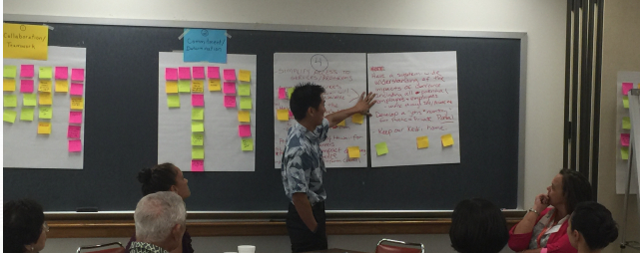

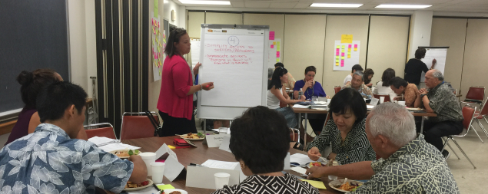
Unified State Plan
Under the Workforce Innovation and Opportunity Act (WIOA), the Governor of each State must submit a Unified or Combined State Plan to the Secretary of the U.S. Department of Labor that outlines a four-year strategy for the State’s workforce development system. Our committee provides oversite on production of the State plan which is largely based on goals set by the County Workforce Councils.

